Michigan 4-H Outbound
International Travel
Scholarship Awards

2016-17 SCHOLARSHIP APPLICATION PACKET

Award Timeline:

May 21, 2008
Request for nominees announced

August 1, 2008
Application deadline

Scholarships are available through the Michigan 4-H Foundation to support 4-H international exchange travel. For 2016-17, four $1,000 scholarships are available for international travel. They are funded with support from the Woman’s National Farm and Garden Association and the Michigan 4-H International Endowment Fund created by Michigan 4-H IFYE Alumni.

All scholarship recipients must fulfill several requirements once they return from their host country. A contract is signed. Any participant that fails to fulfill the requirements in the contract or to make alternative fulfillment plans will be responsible for repaying the entire scholarship amount.

All outbound delegates are expected to complete a program evaluation when they return from their host country. All program evaluations are due in the State 4-H Office by September 1, 2017.

Scholarships are available as follows:
- One $1,000 travel scholarship available per year for up to four 4-H travelers. Traveler must be enrolled in 4-H during travel year.
- Scholarship recipients are awarded $750 pre-travel and reimbursed the final $250 after all reporting and documentation requirements have been fulfilled.

Requirements for all scholarship award recipients to complete by December 1 of travel year:
- Write an article (1-2 pages or more) on one or more concepts learned through this program. Submit at least two good photos with the article to the 4-H international exchange coordinator.
- Develop a display poster on your experience. This should include photos and information telling about your experience to be used as part of your talks and presentations.
- Give a talk/report to two or more groups in your county. These may include 4-H groups, service clubs (i.e. Kiwanis, Rotary), school classrooms, etc.
- Each scholarship recipient is asked to attend and do a presentation at a Woman’s National Farm and Garden Association International Tea. These take place annually in late summer or early fall. Specific tea dates and locations will be provided in the award announcement.
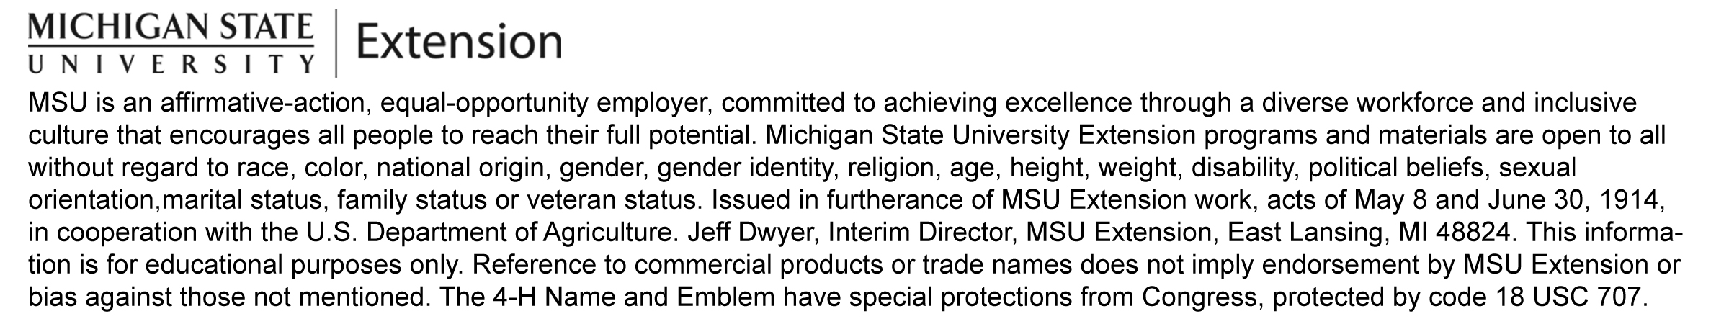
- After travel is completed, submit receipts of documented travel expenditures equal to total scholarship amount.

Michigan 4-H Outbound International Travel Scholarship Application

SECTION 1
Name ___________________________________________________________________________ M ____ F ____
County of 4-H membership _______________________4-H Club or Group__________________________________
Mailing Address ________________________________________________________________________________
City ____________________________________ State __________ Zip Code ______________________________
Home Phone No. ( ) ___________________________________ Cell ( ) _____________________________
Email _____________________________________________________Age________________________________
Date of Birth ___________________ Current Grade in School _____ School Attending ________________________
2016-17 Host Country:

All scholarship application materials must be submitted, postmarked by May 31, 2017 to:
4-H International Exchange Coordinator
446 West Circle Drive, Room 240
Michigan State University
East Lansing, MI 48824
_____IFYE
_____ Australia
_____ Costa Rica
_____ Japan 8-Week Program
_____ Japan 4-Week Program
_____ Finland/Norway
_____ Belize
_____ Poland

SECTION 2

1. Why do you want to travel to the country you have selected for your summer exchange experience?

- Exchange programs are part of the 4-H Leadership and Civic Engagement programs. Please explain how you have been involved in leadership, citizenship and/or global and cultural education activities in 4-H, school, your community, or other ways.

- If you were asked to develop a photo story or video about the community/town/city where you live, please list 15 different things you would include in your presentation.

- What cultural project will you share with your host family and hosting organization? The cultural project should focus on an aspect of American culture that is important to you. Example: bake or cook an American dish or treat, demonstrate a skill, teach a game or song or make a craft.

Note: All travel scholarship award applications must be post-marked by May 31, 2017.

SECTION 3

I, ___________________ would like to apply for this scholarship. I understand that if I am awarded a scholarship I will complete all the requirements stated, by the deadline given. Any participant that fails to fulfill the requirements in this contract will be responsible for repaying the entire scholarship amount.

_________________________________________ _______________________
Signature of Delegate Date

_________________________________________ _______________________
Signature of Parent/Guardian Date

I support this application: ______________________________________________ Date ____________________ Signature of MSU Extension 4-H Program Coordinator

